 | FOMMS 2027 – Extended Abstract  Proceedings of the 10th Foundations of Molecular Modeling and Simulation  Snowbird, Utah, USA, July 11-16 (2027)
Replace This Text with the Title of Your Extended Abstract with Title Capitalization That Can Run Multiple Lines
Firstname Q. Lastnameª, Givenname R. S. Surname Jr.^{ab}, and Personwith MULTIWORD LASTNAME^{b*}
ª Provincial University, Department of Chemical Engineering, City, Province, Country
^{b} State College, Engineering Department, City, State, Country
* Corresponding Author: author.email@someuniversity.ca
Keywords: Choose an item., Choose an item., Choose an item., Choose an item., Choose an item., more keywords separated by commas

Background and AIMS
FOMMS 2027 prefers that all abstracts have these five sections. Note the style is PSE_BulletedList.
- Background and Aims
- Methodology
- Results
- Conclusions
- References
Methodology
Regular text uses the PSE_Text style. Please do not add spaces between paragraphs. Paragraphs will indent automatically and will hyphenate automatically. Do not add extra paragraph spaces between sections. The abstract must be at least 1 page and at most 2 pages long.
Results
Results go here.
Conclusions
One-Column Tables
Use the Insert | Table feature to insert a table with a single column width, inline in the text. Use PSE_TableCaption for the caption and PSE_TableContent for the table itself.
Table 1. Caption for the table. Multi-line table captions will be fully justified. The style is PSE_TableCaption.
Stream | Description | Flow
Feed | A mixture of MeOH, EtOH, & BuOH. | 11.2 kmol/hr
Side Draw | Mostly ethanol | 115.0 kmol/hr
Distillate | Mostly methanol | 21.5 kmol/hr
Bottoms | Mostly butanol | 110 kmol/hr
One Column-Width Figures
The column width is 8.5 cm. Insert the figure in its own paragraph with style PSE_FigureAndCaption. Insert the figure. On the next line, type the figure caption, and use PSE_FigureAndCaption style.
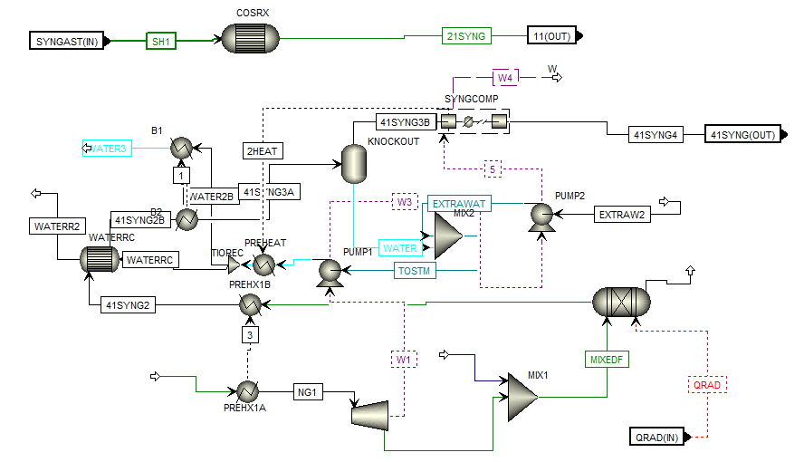
Figure 1. Example 1-column figure with a short caption. Max width is 8.5 cm.
Equations in the Text
Equations should look like the following. Use the Equation Editor in Microsoft Word (Alt + = or Insert | Equation). Then use PSE_Equation for the style. Add the equation reference numbers in parenthesis after the equation inline, and use tabs until the equation numbers are aligned properly (equation numbers and whitespace should all use PSE_Equation). Do not add additional space above or below equation; the style will handle it.
$f\left(x\right)=μ\int_{0}^{∞}{\frac{1}{x}dx}$ (1)
$f\left(x\right)=αβ\int_{0}^{∞}{\frac{1}{x}dx}+y/x$ (2)
You can use LaTeX format or UnicodeMath format if you prefer. Here is an example of a matrix that was made using LaTeX. To add a LaTeX format equation, hit Alt + = or Insert | Equation to add a new equation, and make sure the Conversions is set to LaTeX in the Editor ribbon (you should only need to do this the first time).
$A=\{\begin{matrix}a & b & c \\ d & e & f \\ g & h & j\end{matrix}\}$ (3)
Code
You can use the style PSE_CodeInline to format computer code inline within the text, such as a function name. For code blocks, use PSE_Code as demonstrated below.
for i in range(NPoints):
T.append(600 + (400) * (i/(NPoints-1)))
P.append( 2 + (50) * (i/(NPoints-1)))

random.shuffle(P)
Definitions, Theorems, and Block Quotes
You can use the PSE_Definition styles and PSE_TheoremTitle styles to create definitions and terms in your text. PSE_Definition also works well as a block quote format.
Theorem 1
Then this text is where your theorem is declared, and you can describe it across multiple lines.
Term Being Defined
This works well for definitions too.
ACKNOWLEDGEMENTS
Please acknowledge your funders in this section, with grant or funding numbers as appropriate. Note that most funding agencies require this. Delete section if not used.
REFERENCES
- Author FN, Suffix AB Jr, Multiple Surname GV, Roman BC III. Title of the paper in sentence case. Abbrev J Title 4:32-42 (2027) https://doi.org/10.1234/56789.10
- Inventor FN. Title of the patent in sentence case. US Patent 3,765,134. (2019)
- Author FN, Other SD. Capitalized Title of the Book. Publisher (2021). ISBN 123-4-5678901-2-3
- Author FN, Other CA. Title of the section of the book. In: Capitalized Title of the Edited Book. Ed: Editor QC, Other JC. Publisher (2022)
- Webpage author. http://hyper.link/deep/link.html [accessed Date]
© 2027 by the authors. Licensed to PSEcommunity.org and PSE Press. This is an open access article under the creative commons CC-BY-SA licensing terms. Credit must be given to creator and adaptations must be shared under the same terms. See https://creativecommons.org/licenses/by-sa/4.0/


